New Public Drinking Water System Application
Utah Division of Drinking Water

An applicant for a new public drinking water system must submit two forms: (1) New Public Drinking Water System Application and (2) Project Notification Form (PNF). This application identifies information required to establish a new public water system (PWS). Note that some of the information requested may not apply to your system. The PNF accompanies plans and specifications for drinking water facilities requiring plan approval. Visit the Division of Drinking Water (DDW) website (drinkingwater.utah.gov) for additional information.

Public Drinking Water System Name

Applicant Information

1. Name:
 | Address:
 | City: |  |  |  |  |  |  |  | Zip Code:
 | E-Mail:
 | Business Phone:
 | Cell Phone:
Administrative Contact ☐ Owner ☐ PWS Manager ☐ PWS Operator ☐
Other: |  | (check all that apply)

Has the applicant read, and is the applicant familiar with, new PWS obligations pursuant to State of Utah Administrative Rules for Public Water Systems, specifically, Rule R309-105, Administration: General Responsibility of Public Water Systems?
Yes ☐ No ☐
 | Applicant Signature |  | Date

PWS Information

2. Service Connection Type
Projected number of service connections at full build-out:

Current number of service connections served by the proposed PWS: (Please list number next to the type of service connection. If needed, add detailed description below.)

Residential |  | Commercial |  |  | Industrial
Agricultural |  | Combined (specify)
Description:
Population Served by the Proposed PWS
Projected population served by the proposed PWS at full build-out: ______________

Current population served by the proposed PWS: (Please list the number of people served next to the appropriate use.)
Residential (year-round):
Residential (between 6 months to 12 months each year):
Residential (less than 6 months per year):
Non-residential use (year-round):
Non-residential use (between 6 months to 12 months each year):
Non-residential use (less than 6 months per year):

PWS Location
County in Utah: |  |  | City/Town:
Address or description:

Operation Period
Is the proposed water service year-round? Yes ☐ No ☐
If the water service is not year-round, identify the period of the proposed seasonal water
service: from |  | to

Category of the proposed PWS (check only one):
☐ Community water system (CWS)
☐ Non-transient non-community (NTNC) water system
☐ Transient non-community (TNC) water system
[Guidance: See Division of Drinking Water Rule R309-100-4(4).]

3. PWS Description
(Describe here the water system’s purpose, intended water users, system components, configurations, etc. Affix an attachment if needed.)

Drinking Water Source
4. Does the proposed PWS have its own existing water source? Yes ☐ No ☐
If yes, identify the existing source name, location (latitude and longitude, NAD83 preferred),
and describe the source:
Have any water quality analyses been made of the source water? Yes ☐ No ☐ N/A ☐
If yes, please attach a copy of the water quality analyses with this form.

[Guidance: The existing water source of a proposed PWS is required to undergo DDW’s plan review process to determine whether it meets the current public drinking water standards. Such standards include construction standards, drinking water quality standards, source protection plan, certified well grout to a depth of 100 feet, etc. If an existing water source does not meet the public drinking water standards, the proposed PWS is required to either develop or acquire a public drinking water source that meets public drinking water standards, or modify the source to meet the standards.]
5. Will the proposed PWS receive drinking water from an existing PWS? Yes ☐ No ☐
If yes, identify the existing PWS name and water system number:

If the proposed PWS will receive drinking water from an existing PWS, will the proposed PWS also develop its own source of water to supplement water delivered from another PWS?
Yes ☐ No ☐ N/A ☐
[Guidance: DDW encourages new water service areas to obtain drinking water through existing public water systems (PWS). Due to extensive regulatory requirements, creation of a new PWS is less preferable than annexing to an existing PWS. Identify any PWS or wholesale connection that could provide drinking water to the proposed area in lieu of creating a new PWS.]
6. Will the proposed water system develop its own water source(s)? Yes☐ No☐
If yes: Proposed new well source? Yes☐ No☐
Proposed new spring source? Yes☐ No☐
Proposed new surface water source? Yes☐ No☐
Proposed new water treatment plant? Yes☐ No☐
Describe the possible new source(s):

[Guidance: No new public water system can be approved by DDW without a drinking water source. The common options for a new water source are wholesale connection, wells, springs, and surface water treated in accordance with Federal and State Rules. Identify the well, spring, or surface water body, which may serve as the proposed new water system's water source.]

Engineering Review

7. A new water system will be required to provide detailed information for review, i.e., engineering plans and specifications prepared by a professional engineer licensed to practice in Utah, of existing and proposed drinking water facilities, including source, storage, pump, distribution system, etc. This review is to ensure compliance with the current design and construction standards for public drinking water systems and to determine whether a Plan Approval to construct and an Operating Permit to allow the new water system be placed in service can be issued. A new water system’s rating becomes “approved” after it obtains an Operating Permit from DDW.

Do you have a licensed engineer who will prepare the plans and specifications for the new PWS? Yes ☐ No ☐
If yes, identify the name and contact information of the licensed engineer:

Name:
Company:
Telephone:
E-Mail:

[Guidance: Contact the engineering staff at (801)536-4200 for information related to drinking water facility construction standards and plan review requirements. See Division of Drinking Water Rules R309-500 through 550.]

Capacity Development Business Plan

8. Regarding the capacity development business plan requirement for the proposed PWS outlined in Division of Drinking Water Rule R309-800, Capacity Development Program, identify the proposed water system’s category below (check only one).
☐ Community water system (CWS): Capacity Development Business Plan is required.
☐ Non-transient non-community (NTNC) water system: Capacity Development Business Plan is required.
☐ Transient non-community (TNC) water system: Capacity Development Business Plan is not
required.

[Guidance: Contact the DDW Permitting Section Manager at (801)536-4200 for information related to the capacity development plan. See Division of Drinking Water Rule R309-800.]

Source Protection

9. A Preliminary Evaluation Report (PER) is required for a new drinking water source, or for a source that has not previously been reviewed and approved by the Division. A licensed geologist (PG) or engineer (PE) must prepare the Delineation Report section of the PER for a groundwater source.

If you plan to use a well or spring, do you have a PG or PE who will prepare the Delineation Report for the source(s)? Yes ☐ No ☐
If yes, identify the name and contact information of the licensed geologist or engineer:
Name:
Company:
Telephone:
E-Mail:

[Guidance: Contact the source protection staff at (801)536-4200 for information related to source protection requirements. See Division of Drinking Water Rules R309-600 and R309-605.]

Certified Water Operator

10. All Community and Non-transient non-community (CWS and NTNC) drinking water systems must obtain a certified operator that has Distribution certification to the level of the water system's population. Any water system that treats surface water or water under the direct influence of surface water must have a Treatment operator certified at the grade of the water system depending on the population served by the water system.
Will this new PWS be required to have a certified water operator? Yes ☐ No ☐
If you have made an arrangement with a certified water operator, identify the name and contact information of the water operator:
Name:
Company:
Telephone:
E-Mail:
Cert. No.:

[Guidance: Contact the DDW Technical Assistance Section Manager at (801)536-0042 for information related to water operator certification. See Division of Drinking Water Rule R309-300.]

Drinking Water Monitoring and Reporting

11. All drinking water systems are required to comply with the water quality monitoring and reporting requirements of drinking water system sources and distribution system. The samples required depend upon the type of water system, the type of source water, the type of treatment provided, the population served, etc. Upon Division review of the information provided, a system-specific monitoring schedule will be established and provided to the water system management.

[Guidance: Contact the Rules Section Manager at (801)536-0042 for information related to monitoring, reporting, and compliance requirements. See Division of Drinking Water Rules R309-200 through 225.]

Water Rights

12. In which Division of Water Rights Region is the proposed PWS located (see Attachment 1)?
☐ Northern Regional Office (Logan)
☐ Weber River/Western Regional Office (SLC)
☐ Utah Lake/Jordan River Regional Office (SLC)
☐ Eastern Regional Office (Vernal)
☐ Southeastern Regional Office (Price)
☐ Sevier River/Southern Regional Office (Richfield)
☐ Southwestern Regional Office (Cedar City)
[Guidance: DDW may wish to consult with the State Engineer about water rights issues for the proposed public water system. Identify in #12 and #13 the Division of Water Rights Region in which the proposed PWS is located, and any Division of Water Rights personnel with whom representatives of the proposed PWS has communicated. Contact Division of Water Rights at (801)538-7240 for questions related to water rights.]

13. Identify the State Engineer's Office representative you have contacted (see Attachment 1):

Name:
Telephone:
E-Mail:

14. With respect to water rights "already in hand" for the proposed PWS:

a. Water rights number(s):
b. Nature of use (e.g., municipal, domestic, irrigation, etc.):
c. Acre-feet, cubic feet per second (CFS), other:
d. Do the Division of Water Rights’ records show the ownership of water rights in the
name of the PWS? Yes ☐ No ☐ (Explain)
e. Change application filed? Yes☐ No☐ N/A☐ [Note that change applications may take up to 6 months for the associated advertising and protest processes.]
f. Point of diversion (POD) change filed? Yes☐ No☐ N/A☐
g. Nature of use change filed? Yes☐ No☐ N/A☐
[Guidance: DDW Rules require that a public drinking water system must have a valid right to use the water for its water sources, i.e., the water rights must be classified by the State Engineer as domestic or municipal drinking water rights. The State Engineer may not necessarily change irrigation, mining, stock-watering or agricultural water rights to domestic or municipal drinking water rights. Identify the water right number, types, and quantities that the proposed new public water system currently owns or controls.]

15. With respect to water rights intended to be acquired for the proposed PWS:

- Have you identified prospective water rights sellers (e.g., private party, etc.)?
Yes☐ No☐ N/A☐
If yes, describe the prospective seller:

[Guidance: If the proposed PWS will purchase as-yet un-acquired water rights, identify the prospective seller of these water rights.]

b. Is any water rights acquisition contract appropriately contingent upon the State Engineer's change application approval? Yes☐ No☐ N/A☐
[Guidance: The State Engineer will not pre-judge change applications. Acquisition contracts should always allow for cancellation by the buyer in the event of change application denial by the State Engineer.]

16. With respect to water rights that would be provided by another entity for the proposed PWS:

- Have you contacted or entered into an agreement with an entity to provide drinking water under its water rights? Yes☐ No☐ N/A☐
If yes, identify the prospective water rights provider here (e.g., water conservancy
district, etc.):

[Guidance: If the proposed public water system will receive the water supply from an entity that holds the corresponding water rights, identify the prospective providers of these water rights.]

Division of Public Utilities

17. Have you contacted the Division of Public Utilities (DPU) to register the proposed drinking
water system? Yes ☐ No ☐ N/A ☐ (Explain)

If yes, identify the utility analyst at DPU who has been contacted:
Name:
Telephone:
E-Mail:

[Guidance: All public drinking water systems that sell water or charge water users must apply and be approved for either a “Certificate of Public Convenience and Necessity (CPCN)” or an Exemption. The CPCN form can be found on the website of the Division of Public Utilities (DPU): http://publicutilities.utah.gov/forms.html. Identify in #17 and #18 any DPU staff consulted and their preliminary assessment of whether the proposed new water system will be exempt or regulated by DPU. If needed, contact DPU at (801)530-7622.]

18. Preliminary indication from DPU of the new PWS's regulatory status:
☐ Letter of Exemption ─ Nonprofit/mutual PWS serving members only;
☐ Certificate of Convenience & Necessity ─ For-profit PWS serving public;
☐ Not Applicable or other (Explain)

Fire Authority
19. Will the distribution system be equipped with fire hydrants? Yes ☐ No☐
Does the fire authority require this system to supply fire suppression water? Yes ☐ No☐
Identify the local fire code officials you have contacted with respect to fire suppression requirements:
Name:
Fire District:
Telephone:
E-Mail:
Required fire flow (in gallons per minute):
Required fire flow duration (in minutes):

[Guidance: If the proposed water system will have fire hydrants in its distribution system or is required to supply water for fire suppression, the water system design will be required to meet the storage volume, flow and pressure requirements for fire flow.]

Miscellaneous

20. Will the proposed water system construction involve storm water or wastewater discharges, or septic systems? Yes ☐ No☐
[Guidance: A proposed water system or new development may need to obtain permits or approvals from the Utah Division of Water Quality, local Health Department, or local government such as city or county. If the proposed water system project involves storm water discharge during construction, wastewater discharge or septic systems, please contact the Utah Division of Water Quality at (801)536-4300 and/or the local Health Department.]

Northern Regional Office (LOGAN)
Will Atkin, Regional Engineer
1780 North Research Parkway, Suite 104
North Logan, UT 84341
Phone: (435) 752-8755
Fax: (435) 752-0062
Email: willatkin@utah.gov

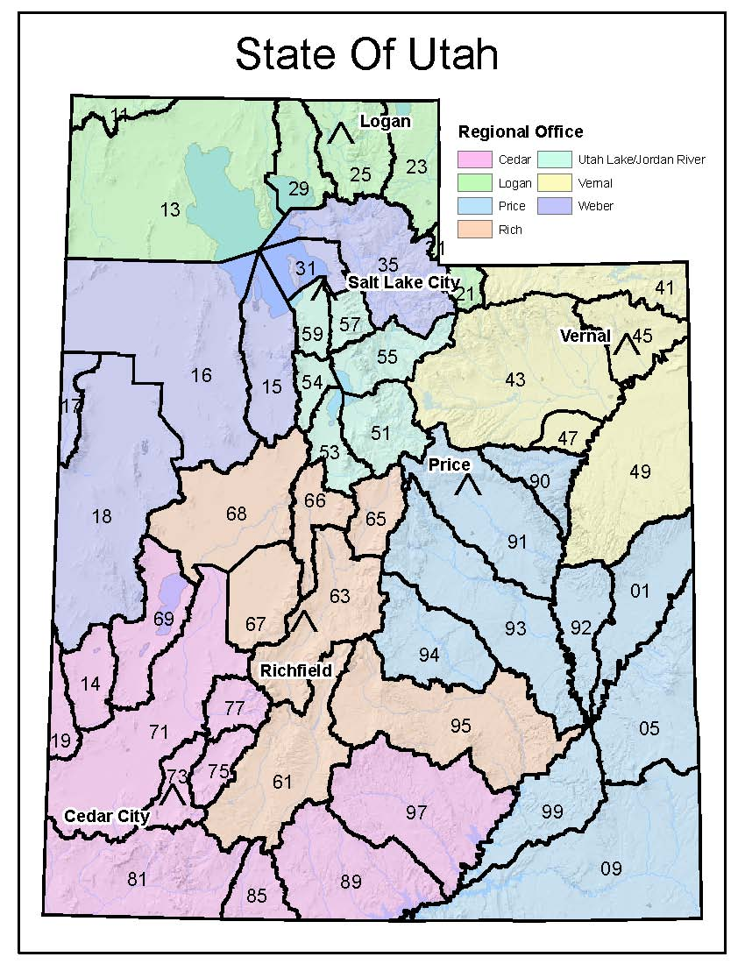
Weber River/Western Regional Office (SLC)
Michael Drake, Regional Engineer
1594 West North Temple, Suite 220
P.O. Box 146300
SLC, Utah 84114-6300
Phone: (801) 538-7240
Fax: (801) 538-7467
Email: michaeldrake@utah.gov

Utah Lake/Jordan River Regional Office (SLC)
Ross Hansen, Regional Engineer
1594 West North Temple, Suite 220
P.O. Box 146300 SLC, Utah 84114-6300
Phone: (801) 538-7240
Fax: (801) 538-7467
Email: rosshansen@utah.gov

Eastern Regional Office (VERNAL)
Andrew Dutson, Regional Engineer
State and County Building
152 East 100 North
Vernal, Utah 84078-2126
Phone: (435) 247-1514
Fax: (435) 789-8343
Email: andrewdutson@utah.gov

Southeastern Regional Office (PRICE)
Marc Stilson, Regional Engineer
319 North Carbonville Road
P.O. Box 718
Price, Utah 84501
Phone: (435) 613-3750
Fax: (435) 613-3755
Email: marcstilson@utah.gov

Sevier River/Southern Regional Office (RICHFIELD)
Kirk Forbush, Regional Engineer
130 North Main Street
P.O. Box 664
Richfield, Utah 84701-0563
Phone: (435) 896-4429
Fax: (435) 893-8114
Email: kirkforbush@utah.gov

Southwestern Regional Office (CEDAR CITY)
Nathan Moses, Regional Engineer
646 North Main Street
P.O. Box 506
Cedar City, Utah 84721-0506
Phone: (435) 586-4231
Fax: (435) 586-2789
Email: nathanmoses@utah.gov

1. Familiarize with R309-105, Administration: General Responsibility of Public Water Systems

7. Schedule DDW Inspection(s) during Construction
(Keep DDW apprised of construction as it progresses.)
9. Place New Drinking Water Sources and Facilities in Service &
Continue to Comply with Monitoring, Sampling, Operator Certification and Other Requirements
Contact Local Fire Code Official

2. Submit to Division of Drinking Water (DDW) two forms:
“Project Notification Form” and “Supplemental Form for New Public Water System”

6. Obtain Plan Approval from DDW & Start Construction of Drinking Water Sources and Facilities

8. Submit Record Drawings, Water Quality Data and Other Information & Obtain Operating Permit from DDW
4. Identify Drinking Water Source (New versus Existing Public Water Supply) &
Submit New Source Preliminary Evaluation Report (PER) if needed

5. Submit Preconstruction Engineering Plans and Specifications for DDW Review
(R309-500-6(2), Pre-Construction Requirements, Licensed Engineer Stamped Plans and Specifications)

Contact Division of
Public Utilities
(801)530-7622
Contact Division
Of Water Rights
(801)538-7240
3. Prepare and Submit the Capacity Development Business Plan (or the Capacity Development Worksheets) (See R309-800. Capacity Development Program)

